Surfaces Final

**Create a TIN surface in a new drawing**

1. Click http://docs.autodesk.com/CIVIL/2010/ENU/AutoCAD%20Civil%202010%20User%20Documentation/images/ISD/conref-lib/2010/English/Civil_Express-Workshop/sc_ribbon_menu_browser.pnghttp://docs.autodesk.com/CIVIL/2010/ENU/AutoCAD%20Civil%202010%20User%20Documentation/images/ac.menuaro.gifNew.
2. In the Select Template dialog box browse to the **tutorial folder** *<AutoCAD Civil 3D installation location>\Help\Civil Tutorials* Drawing folder on the D drive. Select *Surface.dwt*. Click Open.
3. Click Home tabhttp://docs.autodesk.com/CIVIL/2010/ENU/AutoCAD%20Civil%202010%20User%20Documentation/images/ac.menuaro.gifCreate Ground Data panelhttp://docs.autodesk.com/CIVIL/2010/ENU/AutoCAD%20Civil%202010%20User%20Documentation/images/ac.menuaro.gifSurfaces drop-downhttp://docs.autodesk.com/CIVIL/2010/ENU/AutoCAD%20Civil%202010%20User%20Documentation/images/ac.menuaro.gifCreate Surface http://docs.autodesk.com/CIVIL/2010/ENU/AutoCAD%20Civil%202010%20User%20Documentation/images/ISD/conref-lib/2010/English/Civil_Express-Workshop/surface_create.png.
4. In the Create Surface dialog box, for Type, select **TIN surface**.
5. In the Properties table, specify the following parameters:
   * Name: **EG**
   * Description: **Existing Ground surface from imported contour data**
   * Style: **Contours 5' and 25' (Background)**

**Tip**To select the style, click the Value cell, and then click http://docs.autodesk.com/CIVIL/2010/ENU/AutoCAD%20Civil%202010%20User%20Documentation/images/ISD/conref-lib/2010/English/Civil_Express-Workshop/generic_dot_dot_dot.pngto display the Select Surface Style dialog box.

* + Style: **Contours 5m and 25m (Background)**

**Tip**To select the style, click the Value cell, and then click http://docs.autodesk.com/CIVIL/2010/ENU/AutoCAD%20Civil%202010%20User%20Documentation/images/ISD/conref-lib/2010/English/Civil_Express-Workshop/generic_dot_dot_dot.pngto display the Select Surface Style dialog box.

* + Render Material: **ByLayer**

1. Click OK.
2. In Toolspace, on the Prospector tab, expand the Surfaces collection.

The new surface name is displayed in the http://docs.autodesk.com/CIVIL/2010/ENU/AutoCAD%20Civil%202010%20User%20Documentation/images/ISD/conref-lib/2010/English/Civil_Express-Workshop/surface_tin.pngSurfaces collection in Toolspace on the Prospector tab, but this surface does not contain any data.

**Insert contour polylines into the current drawing**

1. Click Insert tabhttp://docs.autodesk.com/CIVIL/2010/ENU/AutoCAD%20Civil%202010%20User%20Documentation/images/ac.menuaro.gifBlock panelhttp://docs.autodesk.com/CIVIL/2010/ENU/AutoCAD%20Civil%202010%20User%20Documentation/images/ac.menuaro.gif http://docs.autodesk.com/CIVIL/2010/ENU/AutoCAD%20Civil%202010%20User%20Documentation/images/ISD/Tuckerman-WEB/English/1_dinser.pngInsert.
2. In the Insert dialog box, click Browse.
3. In the Select Drawing File dialog box, browse to the [tutorial drawings folder](http://docs.autodesk.com/CIVIL/2010/ENU/AutoCAD%20Civil%202010%20User%20Documentation/files/WS73099cc142f48755f2fc9df120970276f7-9e7.htm#WSfacf1429558a55de1bf144afd80e2cf13-7fff). Select *Surface-1A_I.dwg* *Surface-1A_M.dwg*. Click Open.
4. In the Insert dialog box, specify the following parameters:

**Insertion Point**

* + Specify On Screen: **Cleared**
  + X: **0**
  + Y: **0**
  + Z: **0**

**Scale**

* + Specify On Screen: **Cleared**
  + X: **1**
  + Uniform Scale: **Selected**

**Rotation**

* + Specify On Screen: **Cleared**
  + Angle: **0**

**Explode: Selected**

1. Click OK.
2. Click Home tabhttp://docs.autodesk.com/CIVIL/2010/ENU/AutoCAD%20Civil%202010%20User%20Documentation/images/ac.menuaro.gifView panelhttp://docs.autodesk.com/CIVIL/2010/ENU/AutoCAD%20Civil%202010%20User%20Documentation/images/ac.menuaro.gifviews drop-downhttp://docs.autodesk.com/CIVIL/2010/ENU/AutoCAD%20Civil%202010%20User%20Documentation/images/ac.menuaro.gifExtents.

The drawing zooms to the extents of the inserted polylines.

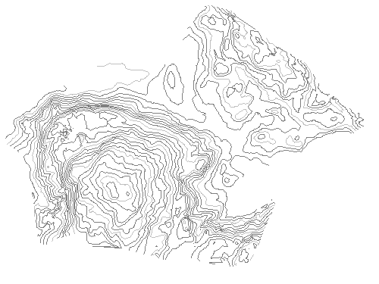

**Add the contours to the surface definition**

1. In Toolspace, on the Prospector tab, expand http://docs.autodesk.com/CIVIL/2010/ENU/AutoCAD%20Civil%202010%20User%20Documentation/images/ISD/conref-lib/2010/English/Civil_Express-Workshop/surface_tin.pngSurfaces http://docs.autodesk.com/CIVIL/2010/ENU/AutoCAD%20Civil%202010%20User%20Documentation/images/ac.menuaro.gifhttp://docs.autodesk.com/CIVIL/2010/ENU/AutoCAD%20Civil%202010%20User%20Documentation/images/ISD/conref-lib/2010/English/Civil_Express-Workshop/surface_tin.pngEG http://docs.autodesk.com/CIVIL/2010/ENU/AutoCAD%20Civil%202010%20User%20Documentation/images/ac.menuaro.gifhttp://docs.autodesk.com/CIVIL/2010/ENU/AutoCAD%20Civil%202010%20User%20Documentation/images/ISD/conref-lib/2010/English/Civil_Express-Workshop/surface_definition.pngDefinition. Right-click http://docs.autodesk.com/CIVIL/2010/ENU/AutoCAD%20Civil%202010%20User%20Documentation/images/ISD/Tuckerman-WEB/English/surface_contours.pngContours. Click Add.
2. In the Add Contour Data dialog box, for Description, enter **Contours from polylines**.
3. Click OK.
4. Draw a selection rectangle around the polylines. Press Enter to complete the selection.

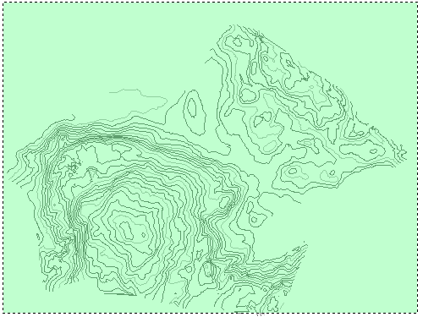

The contours are added to the EG surface definition, and the surface is updated in the drawing. The original contours used to create the surface are still visible in the drawing. You will freeze the original contour layers to hide the original contours.

1. Click Home tabhttp://docs.autodesk.com/CIVIL/2010/ENU/AutoCAD%20Civil%202010%20User%20Documentation/images/ac.menuaro.gifLayers panelhttp://docs.autodesk.com/CIVIL/2010/ENU/AutoCAD%20Civil%202010%20User%20Documentation/images/ac.menuaro.gifLayer drop-down. Next to the **_EG-CONT-MNR** and **_EG-CONT-MJR** layers, click http://docs.autodesk.com/CIVIL/2010/ENU/AutoCAD%20Civil%202010%20User%20Documentation/images/ISD/conref-lib/2010/English/Civil_Express-Workshop/Layer_Thaw.png. Click in the drawing to exit the Layer list.

The layers are frozen http://docs.autodesk.com/CIVIL/2010/ENU/AutoCAD%20Civil%202010%20User%20Documentation/images/ISD/conref-lib/2010/English/Civil_Express-Workshop/Layer_Freeze.png.

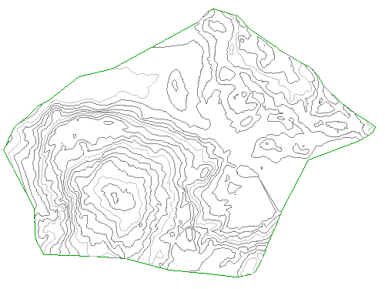

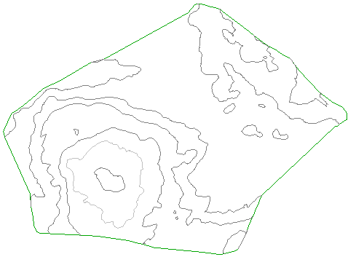

**Display the source polylines and change the surface style**

1. Click Home tabhttp://docs.autodesk.com/CIVIL/2010/ENU/AutoCAD%20Civil%202010%20User%20Documentation/images/ac.menuaro.gifLayers panelhttp://docs.autodesk.com/CIVIL/2010/ENU/AutoCAD%20Civil%202010%20User%20Documentation/images/ac.menuaro.gifLayer drop-down. Next to the **_EG_BREAKLINES** layer, click http://docs.autodesk.com/CIVIL/2010/ENU/AutoCAD%20Civil%202010%20User%20Documentation/images/ISD/conref-lib/2010/English/Civil_Express-Workshop/Layer_Freeze.png.

The 3D polylines that represent the edge of pavement (EP) of an existing road are displayed on the east side of the site.

**Note**The EP polylines were added to the drawing when you inserted the original surface contours in the previous exercise.

1. Select the surface. Right-click. Click Surface Properties.
2. In the Surface Properties dialog box, on the Information tab, for Surface Style, select **Contours and Triangles**. Click OK.

The surface now shows contours and triangles that illustrate the EG surface triangulation.

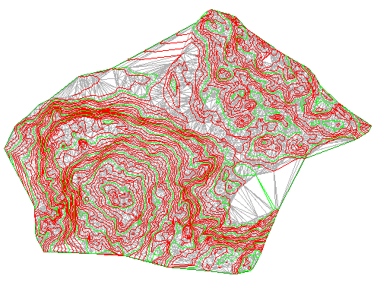

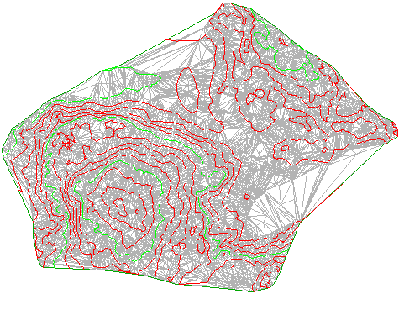

**Create breaklines from the polylines**

1. In Toolspace, on the Prospector tab, expand the http://docs.autodesk.com/CIVIL/2010/ENU/AutoCAD%20Civil%202010%20User%20Documentation/images/ISD/conref-lib/2010/English/Civil_Express-Workshop/surface_tin.pngSurfaceshttp://docs.autodesk.com/CIVIL/2010/ENU/AutoCAD%20Civil%202010%20User%20Documentation/images/ac.menuaro.gif**EG**http://docs.autodesk.com/CIVIL/2010/ENU/AutoCAD%20Civil%202010%20User%20Documentation/images/ac.menuaro.gif http://docs.autodesk.com/CIVIL/2010/ENU/AutoCAD%20Civil%202010%20User%20Documentation/images/ISD/conref-lib/2010/English/Civil_Express-Workshop/sc_surface_definition_icon.pngDefinition collections. Right-click http://docs.autodesk.com/CIVIL/2010/ENU/AutoCAD%20Civil%202010%20User%20Documentation/images/ISD/conref-lib/2010/English/Civil_Express-Workshop/surface_breakline.pngBreaklines. Click Add.
2. In the Add Breaklines dialog box, for Description, enter **Edge of pavement - existing road**. Use the default values for the other fields. Click OK.
3. The Select Objects prompt becomes active. While in this command, use the Zoom and Pan commands to locate the two blue 3D polylines on the east side of the site.

Zoom in close so you can see that the triangles cross over the polylines.

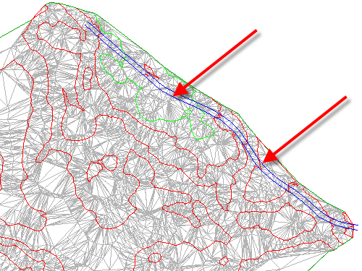

1. Select the polylines. Press Enter.

The surface triangulation is modified. The edge of pavement breaklines are applied, and the TIN surface is adjusted along the breakline edges, modifying the surface triangulation.

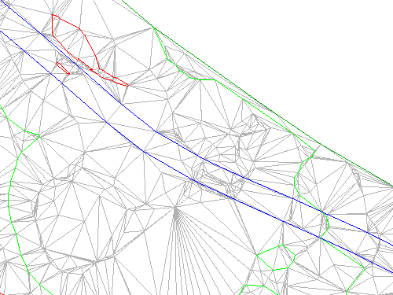

1. Click Home tabhttp://docs.autodesk.com/CIVIL/2010/ENU/AutoCAD%20Civil%202010%20User%20Documentation/images/ac.menuaro.gifView panelhttp://docs.autodesk.com/CIVIL/2010/ENU/AutoCAD%20Civil%202010%20User%20Documentation/images/ac.menuaro.gifviews drop-downhttp://docs.autodesk.com/CIVIL/2010/ENU/AutoCAD%20Civil%202010%20User%20Documentation/images/ac.menuaro.gifExtents.

The drawing window zooms to the extents of the surface. With the breakline data added, the layer that contained the source data for the breaklines can be frozen.

1. Click Home tabhttp://docs.autodesk.com/CIVIL/2010/ENU/AutoCAD%20Civil%202010%20User%20Documentation/images/ac.menuaro.gifLayers panelhttp://docs.autodesk.com/CIVIL/2010/ENU/AutoCAD%20Civil%202010%20User%20Documentation/images/ac.menuaro.gifLayer drop-down. Next to the **EG_BREAKLINES** layer, click http://docs.autodesk.com/CIVIL/2010/ENU/AutoCAD%20Civil%202010%20User%20Documentation/images/ISD/conref-lib/2010/English/Civil_Express-Workshop/Layer_Thaw.png.

**Create an outer boundary from a polyline**

1. Click Home tabhttp://docs.autodesk.com/CIVIL/2010/ENU/AutoCAD%20Civil%202010%20User%20Documentation/images/ac.menuaro.gifLayers panelhttp://docs.autodesk.com/CIVIL/2010/ENU/AutoCAD%20Civil%202010%20User%20Documentation/images/ac.menuaro.gifLayer drop-down. Next to the **_EG-BNDY** layer, click http://docs.autodesk.com/CIVIL/2010/ENU/AutoCAD%20Civil%202010%20User%20Documentation/images/ISD/conref-lib/2010/English/Civil_Express-Workshop/Layer_Freeze.png. Click in the drawing to exit the Layer Control list.

A blue polyline, which represents the extents of the site, is displayed. This polyline was imported with the original surface contours.

1. In Toolspace, on the Prospector tab, expand the http://docs.autodesk.com/CIVIL/2010/ENU/AutoCAD%20Civil%202010%20User%20Documentation/images/ISD/Tuckerman-WEB/English/surface_tin.pngSurfaceshttp://docs.autodesk.com/CIVIL/2010/ENU/AutoCAD%20Civil%202010%20User%20Documentation/images/ac.menuaro.gif http://docs.autodesk.com/CIVIL/2010/ENU/AutoCAD%20Civil%202010%20User%20Documentation/images/ISD/Tuckerman-WEB/English/surface_tin.png**EG**http://docs.autodesk.com/CIVIL/2010/ENU/AutoCAD%20Civil%202010%20User%20Documentation/images/ac.menuaro.gif http://docs.autodesk.com/CIVIL/2010/ENU/AutoCAD%20Civil%202010%20User%20Documentation/images/ISD/conref-lib/2010/English/Civil_Express-Workshop/sc_surface_definition_icon.pngDefinition collections. Right-click http://docs.autodesk.com/CIVIL/2010/ENU/AutoCAD%20Civil%202010%20User%20Documentation/images/ISD/conref-lib/2010/English/Civil_Express-Workshop/surface_boundary.pngBoundaries. Click Add.
2. In the Add Boundaries dialog box, specify the following parameters:
   * Name: **EG - Outer**
   * Type: **Outer**
   * Non-Destructive Breakline: **Cleared**
   * Mid-Ordinate Distance: **1.0000**
3. Click OK.
4. Select the blue polyline.

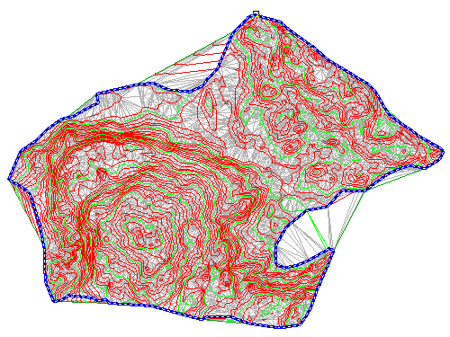

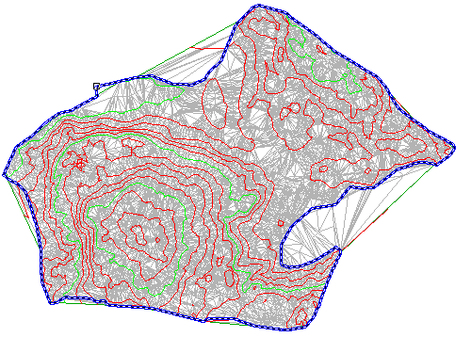

The boundary is added to the surface definition, and the surface display in the drawing is clipped to the area that is defined by the new outer boundary.

**Hide the polyline and change the surface style**

1. Click Home tabhttp://docs.autodesk.com/CIVIL/2010/ENU/AutoCAD%20Civil%202010%20User%20Documentation/images/ac.menuaro.gifLayers panelhttp://docs.autodesk.com/CIVIL/2010/ENU/AutoCAD%20Civil%202010%20User%20Documentation/images/ac.menuaro.gifLayer drop-down. Next to the **_EG-BNDY** layer, click http://docs.autodesk.com/CIVIL/2010/ENU/AutoCAD%20Civil%202010%20User%20Documentation/images/ISD/conref-lib/2010/English/Civil_Express-Workshop/Layer_Thaw.png.
2. Select the surface. Right-click. Click Surface Properties.
3. In the Surface Properties dialog box, on the Information tab, for Surface Style, select **Contours 5' and 25' (Background)Contours 5m and 25m (Background)**. Click OK.

In the selected surface style, contours are displayed in muted colors at broad intervals. This display allows the major surface features to remain visible while you focus on other aspects of the site design.

