Office 2 Performance Based Test

Select One from Each Program Covered in Office2 (Word, Excel, and Access) Create a Folder in your Office 2 folder called Final and save each project into the folder. Save as Final and the Program and the Number. So for example, number 2 from the Word section below would be saved as FinalWord2 in the Final folder.

**Word** (select one number from below, if there are 2 letter parts, do both)



**a Formatting a Newsletter**

**Problem:** You are the editor of the Smith Family newsletter. It is your responsibility to create a monthly newsletter that is both attractive and informative. You need to create a nameplate and then merge the newsletter information as illustrated in Figure W6B – 1. You need to create the text box.

**Instructions:** Perform the following tasks.

1. Change all margins to .75-inch.

2. Create the nameplate using the formats identified in Figure W6B – 1. Create a continuous section break below the nameplate and format section 2 into two columns.

3. Insert the clip art picture (or one close to it) as shown in Figure W6B – 1 and position it as illustrated.

4. Insert the Smith Family data from this document into section 2 below the nameplate..

5. Format the newsletter according to Figure W6B – 1. Create the text box as shown in the figure. Use the Format Painter button to automate some of your formatting tasks.

6. Save the document with **FinalWord1a** as the file name.

7. Save the document as PDF.

**b. Letter with Data Source**

Nature Pride Naturals, where you work part-time, is a mail order company specializing in vitamins, herbal remedies, and organic foods and beverages. Your boss has asked you to design an form letter that can be sent to customers thanking them for their orders and listing the new specials. This month, organic teas and multivitamins are featured items. The teas are 100 percent pure organic, handpicked, and are caffeine- and pesticide-free. The multivitamins are available in 50-, 100- and 200-caplet bottles(use a multilevel ist for this). You must also inform the customers that you have enclosed a coupon for their next order. If they spent less than $50.00 they received a 10 percent off coupon; If they spent more than $50.00, they received a 15 percent off coupon (use an IF field for this). Obtain or make-up the names and addresses of at least 5 people and use them as records in the data source. Create a directory of the data source records. Add accompanying labels or envelopes for the form letters.

**2.**

**a. Form Letter with Data Source**

You work part time at HomeCare, a home health care service. Your boss has just announced that all company computers are being upgraded to run Office 2007. He needs to schedule training sessions for all employees in the two departments he oversees, accounting and communications. He has asked you to create a memo that can be sent to both departments and gives the pertinent information. Use a suitable memo template and include the following information. The memo should be sent to both departments. The accounting department should be informed that they are going to receive training on Word 2007, and the communications department (use an IF field in the To: portion of the memo). The training session for Accounting will be held on March 26th from 1-4 pm; the training session for communications will be the same day from 8-11 am. Both sessions will meet in Conference Room G. Merge and save the memos as FinalWord2a memos. Merge the data source to a directory. Convert the directory to a table and apply formatting to make the table more attractive and readable. Save the table as FinalWord2a table.

**b. Newsletter**

As a part time library assistant, you have been asked to create a monthly newsletter. The library director wants the first issue to publicize the new technology center and to alert patrons to the many events scheduled at the library this month. Especially important, he believes, are the children’s reading program, the used book sale, and upcoming author lectures. He also wants you to list the new releases in both fiction and nonfiction. Use the internet to assist you with elaborating on information presented here. Organize the information and create a newsletter. The newsletter should contain at least two of these graphic elements: clip art image, picture, SmartArt graphic, pull-quote. Enhance the newsletter with a drop cap, WordArt, color, ruling lines, and a page border. Use leader characters to fill the tab space in the issue information line.

**Excel** (select one number from below, if there are 2 letter parts, do both)

**1.** Public Safety Division Budget Proposal

San Pueblo's Public Safety division comprises three departments —Streets and Sanitation, Fire, and Police. The departments have submitted figures comparing this year's budget with next year's budget in four categories (Table below). Develop a template that can be used to prepare each department's budget and the Public Safety division's consolidated total budget within one workbook. Include this year's bud­get, next year's budget, and the variance [(next year's budget - this year's budget) / this year's budget] for each expenditure. Indicate totals where appropriate. Create an embedded chart on the Public Safety division's worksheet comparing the division's expenditures this year and next.

|  |  |  |  |  |  |  |
| --- | --- | --- | --- | --- | --- | --- |
| Table 6-12 San Pueblo's Public Safety Division Expenditures | | | | | | |
|  | Streets and Sanitation | | Fire | | Police | |
|  | Next Year | This Year | Next Year | This Year | Next Year | This Year |
| Equipment | 212000 | 198150 | 62350 | 78345 | 225175 | 220650 |
| Maintenance | 68350 | 62450 | 22750 | 17000 | 98375 | 102500 |
| Miscellaneous | 48125 | 44520 | 37600 | 38200 | 47500 | 32800 |
| Salaries and Benefits | 116000 | 112400 | 198000 | 211000 | 150000 | 162750 |

2. Creating a Consolidated Balance Sheet

Jeans-For-Teens is a New York-based company that sells high-end jeans globally. After launching its Web site five years ago, the company has attracted so many clients from Europe that the own­ers opened a shop in Paris. The New York and Paris shops' assets last year, respectively, were: cash $825,101 and $650,450; accounts receivable $557,190 and $325,860; marketable securities $345,213 and $211,450; inventory $845,258 and $326,120; and equipment $82,250 and $56,200. The liabilities for each store were: notes payable $1,512,381 and $345,000; accounts payable $213,360 and $179,900; and income tax payable $82,100 and $125,350. The stockholders' equity was: common stock $812,300 and $235,000; and retained earnings $324,242 and $162,400.

Design a template as a balance worksheet to reflect the figures above. Include totals for assets, liabilities, and stockholders' equity. Use the template to create a balance worksheet for the New York store, the Paris store, and the consolidated balance worksheet for the corporation.

3. Analyzing Company Profits by Category

Elite Software sells computer software and supplies. Merchandise is divided into six categories base profit margin: individual application packages (22%), integrated application packages (9%), entertainment software (16%), system software (25%), learning aids (18%), and supplies (10%). Last year’s salary data has been collected for the State Street and Western Avenue Stores as shown in the Table below.

Develop a template that can be used to determine marketing strategies for next year. Include sales, profit margins, profits (sales x profit margin), total sales, total profits, and functions to determine the most and least sales, profit margins, and profits. Use the template to create a worksheet for each outlet, a consolidated worksheet for the entire company, and a chart on a separate sheet reflecting the company's profits by category.

|  |  |  |
| --- | --- | --- |
|  | State Street Store | Western Avenue Store |
| Individual applications | $148,812 | $52,864 |
| Integrated applications | 140,135 | 93,182 |
| Entertainment software | 62912 | 72345 |
| System software | 22769 | 25278 |
| Learning Aids | 9562 | 21397 |
| Supplies | 44215 | 34921 |

**Access** (select one number from below)

1. Problem: An auto repair shop needs to maintain information on its jobs and customers. The shop specializes in repair jobs for local car dealers. The database it will use consists of two tables. The Jobs table contains data on jobs the repair shop either has started or has completed for each customer. The Customer table contains pertinent data about the auto repair shop’s customers.

Instructions: The structure for the Jobs table is shown in Table A1A – 1 and the data is shown in Table A1A – 2. The structure for the Customer table is shown in Table A1A – 3 and the data is shown in Table A1A – 4.

1. Create a new database to store the two tables related to the auto repair shop. Call the database, FinalAccess1.

2. Create the Jobs table using the structure shown in Table A1A – 1. Make the Job ID the primary key, no duplicates. Use the name, Jobs, for the table.

3. Add the data shown in Table A1A – 2 to the Jobs table.

4. Save the Jobs table.

5. Create the Customer table using the structure shown in Table A1A – 3. Make the Customer ID the primary key, no duplicates. Use the name, Customer, for the table.

6. Add the data shown in Table A1A – 4.

7. Save the Customer table.

1. Create a split form for the Customer table. Save the form using the name, Customer.
2. Create a report using the Jobs table that lists the Job ID, Job Description, Completion Date, and Quote. Use the Flow style. Title the report Job Summary Report and save it. Your report should display similar to the one shown in Figure A1A – 1 below.

Queries: Save the Query as the number below.

Display and print all fields for all the records in the Jobs table.

1. Display and save the Job ID, Customer ID, and Job Status for all records in the Jobs table.

2. Display and print the Job ID, Customer ID, Job Status, and Quote for all jobs with a job status of C.

3. Display and print the Job ID, Customer ID, Job Status, and Completion Date for all jobs with a completion date after June 1, 2007.

4. Display and print the Job ID, Customer ID, Job Status, and Quote for all jobs with a job status of I and a quote of more than $2000.

5. Display and print the Job ID, Customer ID, Job Status, and Completion Date for all jobs with a job ID that begins with M.

6. Display and print the Job ID, Customer ID, Completion Date, and Quote for all jobs with a completion date before March 30, 2005 or a quote of less than $500.

7. Display and print the Job ID, Customer ID, Job Description, and Quote for the top 3 jobs with a quote greater than $500 and less than $2,000. (*Hint*: Enter a criteria of “>500 And <2000” for Quote.)

8. Display and print the Job ID, Customer ID, Job Status, and Completion Date of all records in the Jobs table sorted in ascending sequence by customer ID. Using a parameter, ask the user to “Enter Status”, and use it to limit the records to just those which match the parameter.

9. Using all the fields, display and print all the records in the Jobs table sorted in ascending sequence by job ID within customer ID.

10. Join the Jobs and Customer tables. Using the fields Job ID, Customer ID, Job Status, Customer Name, and Telephone, display and print all records.

11. Restrict the records retrieved in Step 10 to only jobs with a job status of I. Display and print the results.

12. From the Jobs table, display and print the highest quote with a job status of I.

**Structure of the Jobs table**

|  |  |  |  |  |
| --- | --- | --- | --- | --- |
| Field Name | Data Type | Field Size | Primary Key? | Description |
| Job ID | Text | 4 | Yes | Job number (primary key) |
| Customer ID | Text | 3 |  | Customer ID number |
| Job Description | Text | 25 |  | General job description |
| Job Status | Text | 1 |  | Status of complete (C) or incomplete (I) |
| Completion Date | Date/Time |  |  | Date job is to be completed |
| Quote | Currency |  |  | Customer’s cost for job |

Table A1A – 1

**Data for the Jobs table**

|  |  |  |  |  |  |
| --- | --- | --- | --- | --- | --- |
| **Job ID** | **Customer ID** | **Job Description** | **Job Status** | **Completion Date** | **Quote** |
| M345 | JMS | Grill Work – 67 Chevy | I | 6/30/2007 | 2200 |
| M653 | KSI | Rebuild Tran – 73 Merc | C | 5/12/2007 | 2685 |
| B423 | KSI | Bumper Repair – 55 Nash | I | 9/21/2007 | 400 |
| B746 | ROM | Valve Job – 68 Falcon | C | 4/15/2007 | 700 |
| M236 | TRW | Brake Drums – 69 Linc | I | 6/15/2007 | 2400 |
| M965 | JTC | Re-paint – 39 Ford | C | 3/1/2007 | 1057 |
| B474 | ROM | Door Panels – 71 Falcon | C | 3/27/2007 | 300 |
| B559 | JMS | Heater Repair – 63 Ford | I | 5/6/2007 | 460 |
| B365 | JTC | Windshield Repair – 66 PU | I | 7/22/2007 | 400 |
| M547 | NQR | Floor Boards – 71 Chevy | I | 9/30/2007 | 2500 |
| B147 | NQR | Muffler – 75 LTD | I | 6/26/2007 | 250 |
| B338 | JMS | Tie-rods – 78 GTO | C | 4/17/2007 | 510 |
| M482 | KSI | Shocks – 78 Pontiac | C | 7/21/2007 | 660 |
| B628 | JTC | Gas Tank – 75 Pinto | I | 8/16/2007 | 420 |
| B553 | ROM | Trunk Deck – 65 Galaxy | C | 9/4/2007 | 1080 |
| M182 | JTC | Overhaul – 83 LTD | C | 8/12/2007 | 990 |
| B527 | JMS | Brake Cyl. – 80 Fairlane | I | 9/21/2007 | 890 |
| M982 | NQR | Muffler – 72 Corvette | I | 10/12/2007 | 580 |
| M522 | JTC | Tune-up – 71 Lincoln | C | 4/30/2007 | 490 |
| B932 | JMS | Manifold – 37 P-Arrow | I | 10/16/2007 | 385 |

Table A1A – 2

**Structure of the Customer table**

|  |  |  |  |  |
| --- | --- | --- | --- | --- |
| Field Name | Data Type | Field Size | Primary Key? | Description |
| Customer ID | Text | 3 | Yes | Customer number (primary key) |
| Customer Name | Text | 25 |  | Customer/Dealer name |
| Contact Person | Text | 20 |  | Contact person |
| Telephone | Text | 8 |  | Contact telephone number |

Table A1A – 3

**Data for the Customer table**

|  |  |  |  |
| --- | --- | --- | --- |
| Customer ID | Customer_Name | Contact Person | Telephone |
| JMS | Jacob’s Motor Sales | Jacob Daniels | 555-3451 |
| KSI | Keith’s Sports Cars, Inc. | Keith Moorehouse | 555-6639 |
| ROM | Randy’s Old Makes | Randy Petersen | 555-7877 |
| TRW | Trevor’s Rolling Wheels | Trevor Craig | 555-2258 |
| JTC | Jack’s Timeless Classics | Jack Johnson | 555-9111 |
| NQR | Nick’s Quick Rides | Nick Stone | 555-8890 |

Table A1A – 4

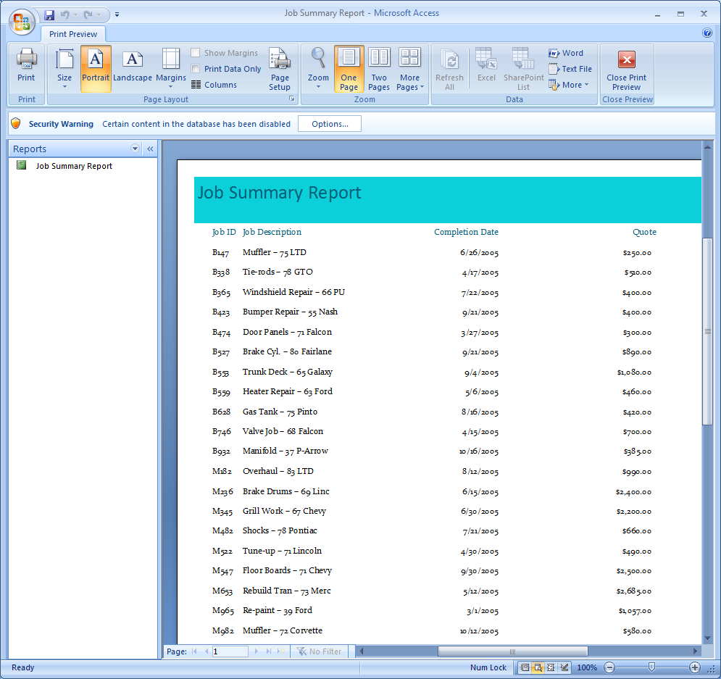

**Figure A1A – 1**

2. Problem: You are a volunteer worker for a not-for-profit organization called Southeast Helping Hands (SHH). SHH serves as a central clearinghouse for temporary shelter information and promotes activities such as home insulation and repair for the elderly and less fortunate. Every organization that joins the SHH as a sponsor is called a member. In addition, each member may have several contacts. Four types of memberships can be purchased on an annual basis: red (R), white (W), blue (B), and yellow (Y). The database consists of two tables: the Members table, which contains data about each member organization, and the Contacts table, which contains data on the individuals who serve as contacts.

Instructions: The structure and data for the Members table is shown in Tables A1B – 1 and A1B – 2, respectively. The structure and data for the Contacts table is shown in Tables A1B – 3 and A1B – 4, respectively.

1. Create a new database to store the tables related to the not-for-profit organization data. Call the database FinalAccess2.

2. Create the Members table using the structure shown in Table A1B – 1. Make the Member ID the primary key, no duplicates. Use the name, Members, for the table.

3. Add the data shown in Table A1B – 2 to the Members table. Save the table.

4. Create the Contacts table using the structure shown in Table A1B – 3. Make the Member ID an index with duplicates. Use the name, Contacts, for the table.

5. Add the data shown in Table A1B – 4 to the Contacts table. Save the table.

1. Create a split form for the Members table. Save the form using the name, Members.
2. Create a report listing all of the data in the Contacts table. Use the Civic style. Name your report Contacts Report, save it. Your report should appear similar to the one shown in Figure A1B – 1 below.

**Queries: Save the Query as the number below.**

1. A member list showing the Member ID, Member Type, and Company sorted by Company within Member Type.

2. A list showing the average number of employees in all member organizations.

3. A list showing the fewest number of employees listed for a company.

4. A list with Member ID, Company, Address, Member Type, Exp Date, and Number of Employees of members whose expiration date is on or before 6/30/2007.

5. A list of members with all their associated contacts. The list should show the Member ID, Company, Contact Name, and Telephone, and should be in ascending order by Contact Name within Company.

6. Using just the Members table, a printed list that includes the Member ID, Company, Member Type, and Number of Employees of all companies that have more than 200 employees and have a member type R.

7. A list showing all members’ dues. List the Member ID, Company, and Number of Employees along with the computed field Member Dues. The dues are calculated by charging a member company $10 per employee. Format the dues using dollar signs and two decimal positions.

8. A count of the companies, grouped by membership type.

9. A count of the companies, grouped by membership type. This time show only the top two companies.

10. A Crosstab query of contacts per company showing a count of the number of telephone numbers.

11. A count of the number of contacts for each member company. Use a parameter to select the company.

**Structure of the Members table**

|  |  |  |  |  |
| --- | --- | --- | --- | --- |
| Field Name | Data Type | Field Size | Primary Key? | Description |
| Member ID | Text | 4 | Yes | Member number (primary key) |
| Company | Text | 20 |  | Company name |
| Address | Text | 20 |  | Street number and name |
| City | Text | 12 |  | City |
| State | Text | 2 |  | State (two-character abbreviation) |
| Zip | Text | 10 |  | ZIP Code + 4 |
| Member Type | Text | 1 |  | Membership type code (R, W, B, or Y) |
| Exp Date | Date/Time |  |  | Memberships are sold in 1-year increments |
| Num Employees | Number |  |  | Number of employees determines dues |

Table A1B – 1

**Data for the Members table**

|  |  |  |  |  |  |  |  |  |
| --- | --- | --- | --- | --- | --- | --- | --- | --- |
| Member ID | Company | Address | City | State | Zip | Member Type | Exp Date | Num Employees |
| 5680 | Southeast Bank | 72100 Far Point | Athens | GA | 30601-1123 | R | 2/15/2007 | 200 |
| 7630 | Southeast Grocery | 16 East 10th St. | Plains | GA | 31780-3401 | B | 3/30/2007 | 85 |
| 4750 | Smith’s Furs | 709 Mitchell Ave. | Mobile | AL | 36601-2030 | Y | 9/14/2007 | 300 |
| 2310 | Birmingham Steel | 13423 Lakeland | Birmingham | AL | 35201-5212 | R | 9/24/2007 | 600 |
| 2360 | American Hook | 4529 Bush | Mobile | AL | 36601-2130 | R | 10/19/2007 | 1400 |
| 5210 | Friendly Insurance | 860 West 5th Ave. | Atlanta | GA | 30301-1125 | B | 11/21/2007 | 957 |
| 8510 | Southtown Bank | 4000 Downer | Athens | GA | 30601-5109 | W | 12/13/2007 | 200 |
| 9600 | Eddo’s Pizza | 422 Noble Rd. | Birmingham | AL | 35201-0254 | Y | 9/28/2007 | 300 |
| 9880 | Stewart’s Clothiers | 5300 Sheffer | Plains | GA | 31780-1152 | Y | 3/1/2007 | 1500 |
| 2584 | National Mortgage | 901 Main St. | Mobile | AL | 36601-5003 | R | 6/12/2007 | 150 |
| 8110 | Southeast Gas | 1101 2nd St. | Athens | GA | 30601-2001 | R | 12/29/2007 | 410 |

Table A1B – 2

**Structure of the Contacts table**

|  |  |  |  |  |
| --- | --- | --- | --- | --- |
| Field Name | Data Type | Field Size | Primary Key? | Description |
| Member ID | Text | 4 | Yes | Member number |
| Contact Name | Text | 20 |  | Contact person’s full name |
| Telephone | Text | 12 |  | Contact’s telephone number at work |

Table A1B – 3

**Data for the Contacts table**

|  |  |  |
| --- | --- | --- |
| Member ID | Contact Name | Telephone |
| 5680 | Mason, Jill | 706-555-5482 |
| 7630 | Harvey, John | 229-555-9833 |
| 4750 | Thurston, Douglas | 251-555-9632 |
| 2310 | Jenkens, Carl | 205-555-5521 |
| 2360 | Cliffton, Maggie | 251-555-3698 |
| 2360 | Dust, Jack | 251-555-9855 |
| 5680 | Phelps, Eileen | 706-555-8989 |
| 5210 | Davis, Linda | 770-555-7700 |
| 7630 | Dobbs, Dale | 229-555-4740 |
| 9880 | Seaman, Deborah | 229-555-5000 |
| 2360 | Jones, Charles | 251-555-8500 |
| 4750 | Freileng, Jean | 251-555-9500 |
| 8110 | Vasquez, Yolanda | 706-555-1242 |
| 2584 | Shepard, Tony | 251-555-5551 |
| 4750 | Buckman, Liz | 251-555-9600 |
| 5680 | Taylor, Tonya | 706-555-5800 |
| 5210 | Sims, Phillip | 770-555-9191 |
| 8510 | Martinez, Carl | 706-555-4455 |
| 8510 | Kapica, Donna | 706-555-6261 |
| 9600 | Fischer, Janet | 205-555-7141 |
| 9880 | Morgan, Sheila | 229-555-2244 |
| 2584 | Strassburg, Romana | 251-555-2310 |
| 8110 | Simon, Tawanda | 706-555-4545 |
| 5680 | Astor, Sam | 706-555-4610 |
| 4750 | Ching, Sima | 251-555-4161 |
| 9880 | Hall, Frank | 229-555-1212 |
| 9600 | Dobbs, Colleen | 205-555-1235 |

Table A1B – 4